**Balsamiq Wireframing**

**Introduction Notes:**

1. <https://balsamiq.com/wireframes/cloud/docs/intro/>
2. <https://balsamiq.com/wireframes/cloud/docs/overview/>

**Working With Controls:**

1. <https://balsamiq.com/wireframes/cloud/docs/adding-controls/>
2. <https://balsamiq.com/wireframes/cloud/docs/shortcuts/>
3. <https://balsamiq.com/wireframes/cloud/docs/shortcuts/#working-with-text>
4. <https://balsamiq.com/wireframes/cloud/docs/editing-controls/#the-data-grid-table-control>

**Exporting and Sharing:**

1. <https://balsamiq.com/wireframes/cloud/docs/linking/>
2. <https://balsamiq.com/wireframes/cloud/docs/fullscreen/>
3. <https://balsamiq.com/wireframes/cloud/docs/exporting/>

**Symbols and Assets:**

1. <https://balsamiq.com/wireframes/cloud/docs/symbols/>
2. <https://balsamiq.com/wireframes/cloud/docs/images/>

**What are Wireframes:**

<https://www.youtube.com/watch?v=I2N7Vl6IOVc>

[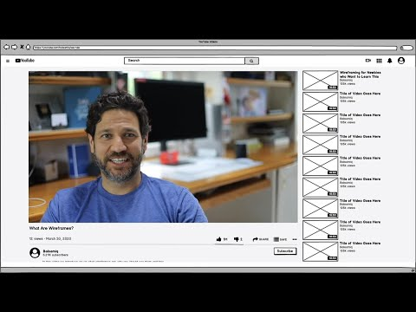](https://www.youtube.com/watch?v=I2N7Vl6IOVc)